JWT-Based Product Inventory Management System
team id: [69a6ab08c3309e5746ec29f7]
Department/Institute: [B.Sc (cs)]
Date: [09/03/2026]
Team Leader:
Thangapandi murugesh C– 24cs3250@gmail.com

Team Members:
- Vignesh R– 24cs3356@gmail.com
- Vetrivijay R– 24cs3254@gmail.com
- Venkatesh kumar G– 24cs3253@gmail.com

Table of Contents

01

Abstract
Executive summary and project overview
02

Problem Statement & Objectives
Identifying pain points and defining goals

03

Customer Problem Statements
User personas and their challenges
04

Technology Stack & Architecture
Tools, frameworks, and system design

05

Data Model & ER Diagram
Database schema and relationships
06

Security & Authentication
JWT implementation and security measures

07

API Design
Endpoint documentation and examples
08

Implementation Summary
Key files and their responsibilities


09

Setup & Results
Installation guide and screenshots
10

Conclusion & Future Work
Lessons learned and roadmap ahead

Abstract

This project presents a secure, user-centric product inventory management system built on the MERN stack (MongoDB, Express.js, React, Node.js) with JWT-based authentication. The application addresses a critical gap in the market: small businesses and individual entrepreneurs need a simple, secure, and centralized tool to manage their inventory, yet many existing solutions are either too complex, expensive, or lack proper data isolation.
Key Features

- JWT-based authentication
- User-isolated CRUD operations
- Search and pagination
- Secure password hashing
- RESTful API design
Our system implements robust JWT authentication with bcrypt-salted password hashing, ensuring user credentials remain secure. Each user maintains isolated access to their own inventory data through MongoDB document-level ownership (storing userId with each product). The API exposes full CRUD operations with search functionality, pagination, and strict route protection via middleware.
Key outcomes include a production-ready RESTful API with clean, well-documented endpoints, secure token-based authentication with ~7-day expiry, and scalable data modeling that supports future enhancements. The architecture is designed for extensibility, with clear separation of concerns between routes, controllers, middleware, and models.

Problem Statement & Objectives

Our Mission
Build an accessible, secure inventory application that empowers users with JWT authentication, ensures user- specific data access through document ownership, and provides intuitive CRUD operations with search functionality—all through clean, well-documented APIs designed for future expansion.
The Problem
Small businesses and individual users struggle to find inventory tools that balance simplicity with security.
Existing solutions often require expensive subscriptions, demand extensive setup time, or lack proper user data isolation—leaving owners frustrated and overwhelmed when they need fast, reliable stock management.
Customer Problem Statements

Problem Statement ID | User Type | Needs & Pain Points | Emotional State
PS-1 | Small Business Owner | Needs fast, real-time stock updates to fulfill orders. Existing tools are either too complex to learn or require expensive subscriptions that strain limited budgets. | Frustrated
PS-2 | Freelancer Seller | Wants a centralized, secure dashboard to track inventory across multiple platforms. Without it, product data gets scattered across spreadsheets and notes, leading to costly mistakes. | Stressed
PS-3 | Shop Manager | Requires real-time CRUD operations for updating quantities as products move in and out. No easy, reliable system exists—outdated data causes inventory discrepancies and customer dissatisfaction. | Anxious
PS-4 | New Entrepreneur | Seeks a lightweight, user-friendly tool to start managing inventory immediately. Many apps require technical expertise to set up or overwhelming feature sets that distract from core needs. | Overwhelmed
These user personas guided our design decisions, ensuring the system addresses real-world pain points through simplicity, security, and immediate value. By focusing on fast setup, intuitive operations, and data protection, we eliminate the barriers that frustrate small-scale inventory managers.
Ideation, Brainstorming & Prioritization

Brainstorming Categories
Our ideation sessions grouped requirements into four key domains:

Authentication & Security
- JWT login with token expiry
- User-specific data access
- bcrypt password hashing
- Role-based access control (future)

Core Inventory
- Product create/update/delete
- List products with pagination
- Search by name
- Quantity tracking

UX & Technical
Additional considerations included responsive UI design and technical architecture decisions.

UX Considerations
- Simple, responsive interface
- Clean product cards
- Fast load times

Technical Stack
- MERN architecture
- REST API endpoints
- MongoDB schema design
- Middleware protection

High Priority (Implemented)
JWT authentication with register/login flows, protected product CRUD operations, MongoDB integration with proper schema, secure route middleware, and basic search functionality
1
Medium Priority (Enhancements)
Advanced filtering by price/quantity ranges, improved error handling with user-friendly messages, UI polish with responsive cards, and request validation
2
Low / Future (Planned)
Role-based admin panel, analytics dashboard with charts, low-stock alerts via email, cloud deployment, and mobile-responsive frontend
3

Technology Stack & Tools

MongoDB
Document-based NoSQL database for flexible schema design and efficient querying of inventory data with userId-based access control

Express.js 5
Lightweight web framework for building RESTful API routes, middleware chains, and request handling with modern async/await syntax

 Node.js ≥20.x
Server-side JavaScript runtime providing event-driven architecture and non-blocking I/O for handling concurrent inventory requests efficiently

JWT & bcryptjs
JSON Web Tokens for stateless authentication with 7-day expiry, bcrypt for secure password hashing with salt rounds, and token payload minimization

Security Utilities
dotenv for environment variables, CORS configured for client origin, Helmet for HTTP header security, and rate limiting on auth endpoints

 Development Tools
Nodemon for automatic server restart during development, MongoDB Compass for database visualization, and Postman/Insomnia for API testing

System Architecture
The system follows a clean three-tier architecture with clear separation between client, API layer, and database. Every product document stores a userId field, enforcing user- scoped data access at the database level and preventing unauthorized cross-user queries.

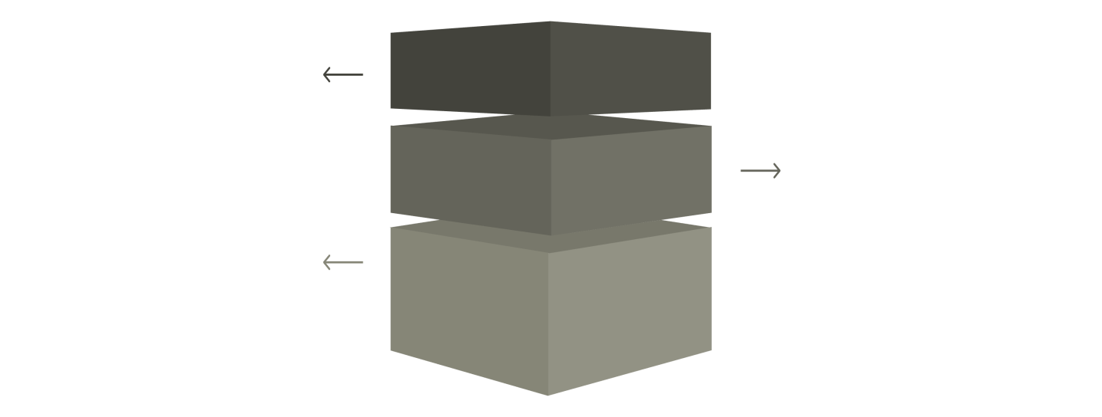
Client Layer
Send HTTP requests from
browsers or apps.

Database Layer
MongoDB stores User and Product documents.

API Layer
Express routes, controllers, and auth middleware.



Client Request
Frontend sends HTTP requests with JWT token in Authorization header to access protected inventory endpoints

API Processing
Express routes invoke middleware to verify tokens, controllers handle business logic, and Mongoose queries MongoDB with userId scoping

Data Storage
MongoDB persists User documents (name, email, hashed password) and Product documents (name, price, quantity, userId) with indexes for performance
Data Model & ER Diagram

User Schema Product Schema

Entity Relationship
One User entity maintains ownership of Many Product entities (1:N relationship). The userId field in each product document creates the foreign key reference, enabling efficient user-scoped queries and preventing unauthorized access to other users' inventory data.
{
name: {
type: String, required: true, trim: true
},
price: {
type: Number, required: true, min: 0
},
quantity: { type: Number,
required: true, min: 0,
default: 0
},
description: { type: String, default: ""
},
userId: {
type: mongoose.Schema.Types.ObjectId, ref: 'User',
required: true
},
createdAt: Date, updatedAt: Date
}
{
name: {
type: String, required: true, trim: true
},
email: {
type: String, required: true, unique: true, lowercase: true
},
password: { type: String,
required: true, minlength: 6
},
createdAt: Date, updatedAt: Date
}



Security & Authentication




Protected Routes
Custom middleware extracts Authorization: Bearer <token> from headers, verifies signature using JWT_SECRET, decodes payload to set req.user.id, and handles missing/invalid tokens gracefully with 401 responses.

Registration & Login
Bcrypt generates random salts and applies 10+ rounds of hashing to passwords before storage. JWT tokens include minimal payload (user ID only) with ~7-day expiry to balance security and user experience.

Security Best Practices
Environment variables protect JWT_SECRET and MongoDB connection strings. Helmet middleware secures HTTP headers. Rate limiting prevents brute-force attacks on /auth endpoints. Strong password policies enforce 8+ characters with complexity.

